 

**Placement Empowerment Program**

***Cloud Computing and DevOps Centre***

**Use Cloud Storage:** Create a storage bucket on your cloud platform and upload/download files. Configure access permissions for the bucket.

Name: Kirubalini S I Department : IT



**Introduction**

Cloud storage offers a scalable and cost-effective way to store and manage your data. This exercise focuses on using Azure Blob Storage, a robust object storage service. You'll learn to create a storage bucket (called a container in Azure) to hold your files. The process involves uploading files to the container and downloading them as needed. Crucially, you'll configure access permissions to control who can access your data, ensuring security and compliance. This hands-on experience provides a foundation for working with cloud storage in real-world applications.

**Objective**

The goal of this project is to:

1. Understand AWS S3 Basics: Learn how to create, configure, and manage an S3 bucket for cloud storage.
2. File Operations: Gain hands-on experience in uploading, downloading, and managing files within the S3 bucket.
3. Access Control: Configure bucket policies and permissions to manage secure and public access to stored data.

**Importance of Storage Bucket(S3)**

The objectives of this exercise, focusing on Azure Blob Storage, are to:

**Create a Storage Container:** Learn to provision a storage container (bucket) within an Azure Storage account.

**Upload Files:** Gain practical experience uploading various file types to the Azure Blob Storage container.

**Download Files:** Understand the process of retrieving files from the storage container.

**Configure Access Permissions:** Master the configuration of access control mechanisms (like Azure RBAC or Access Keys) to secure the storage container and its contents, managing who can read, write, or execute operations on the data**.**

**Understand Cloud Storage Concepts:** Develop a foundational understanding of core cloud storage concepts, including containers, blobs, and access control.

**Practical Application:** Apply these skills to a real-world scenario of storing and managing data in a cloud environment.

**Step-by-Step Overview**

Step1:

Go to the AWS Management Console, Search for and click on S3

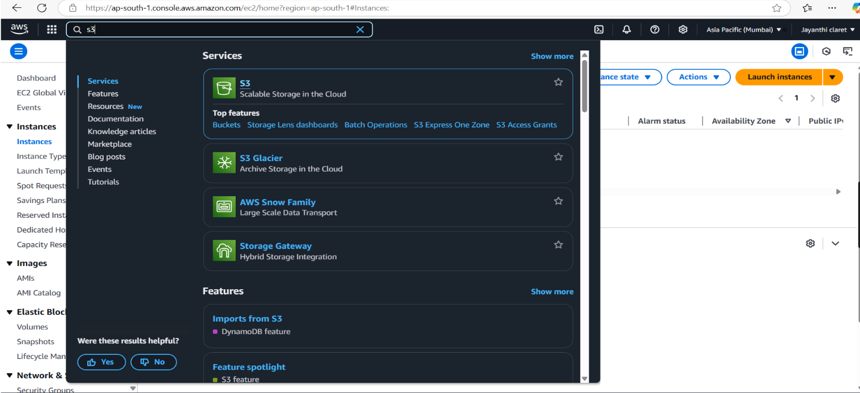

Step 2 :

Click the "Create bucket" button.

Enter a unique bucket name (e.g., my-storage-bucket-123).

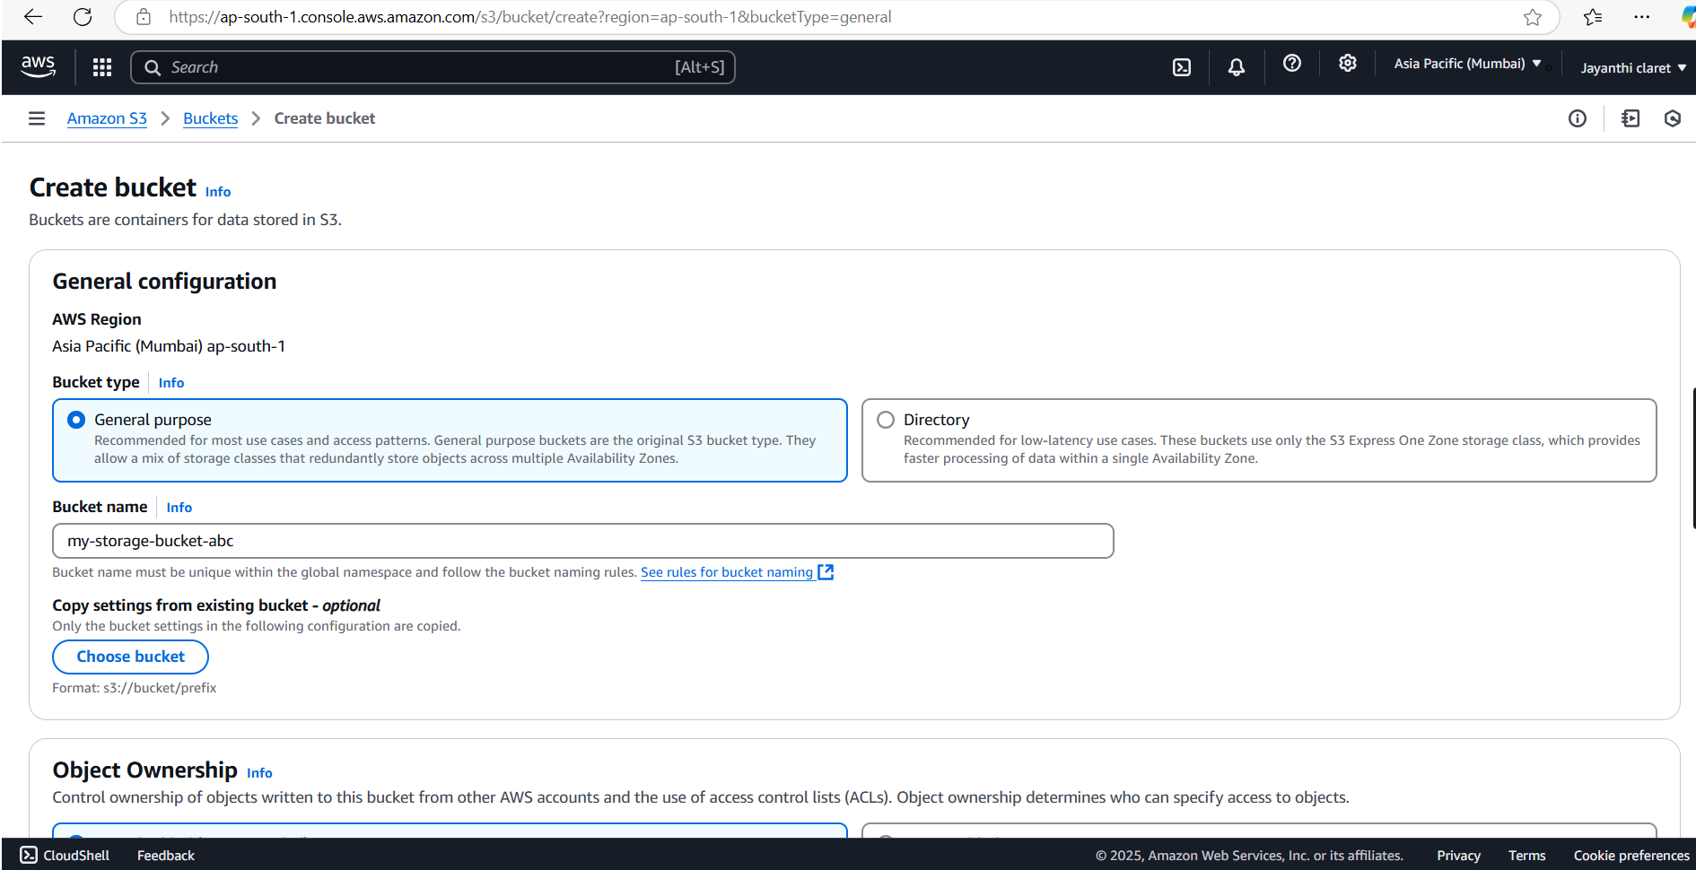

Step 3 :

Leave "Block all public access" enabled for now (you can modify it later).

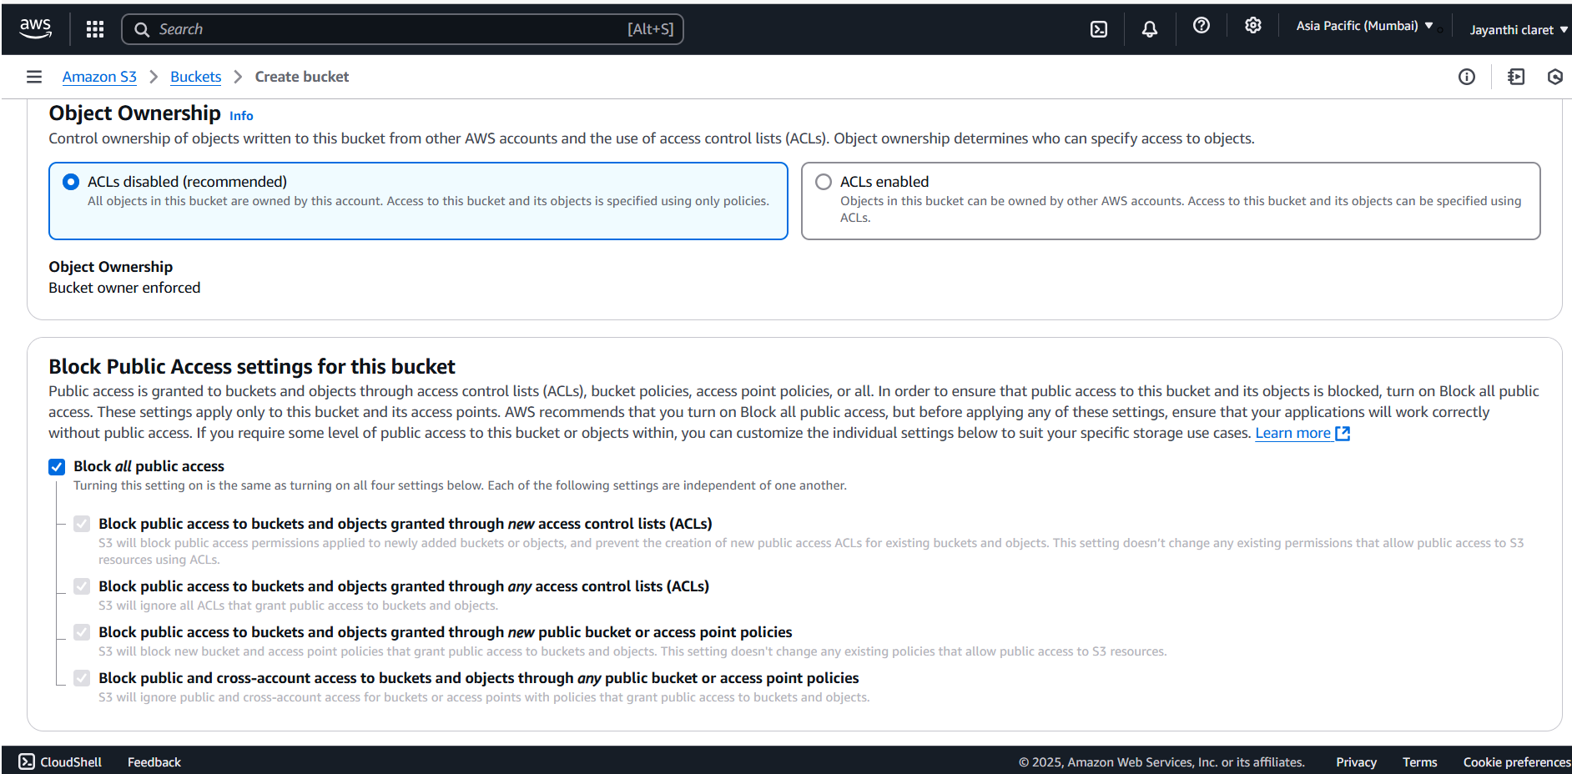

Step 4 :

Click "Create bucket".

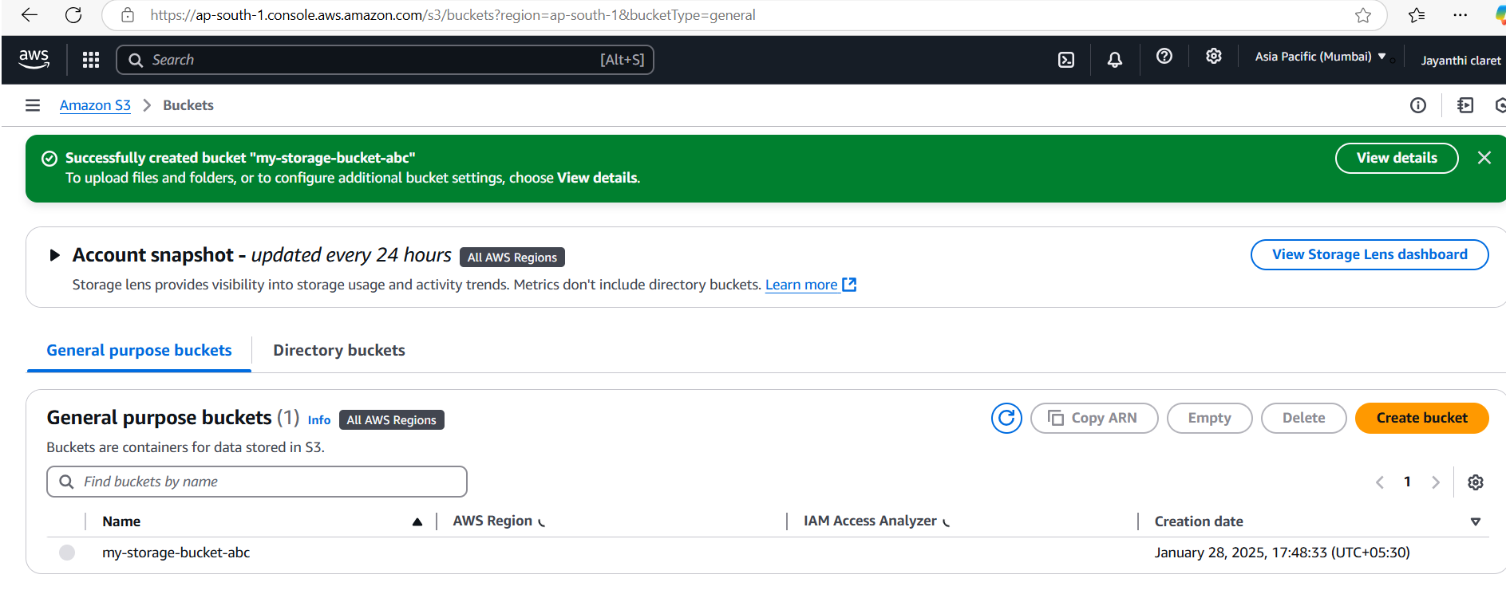

Step 5 :

Open your newly created bucket from the S3 console.

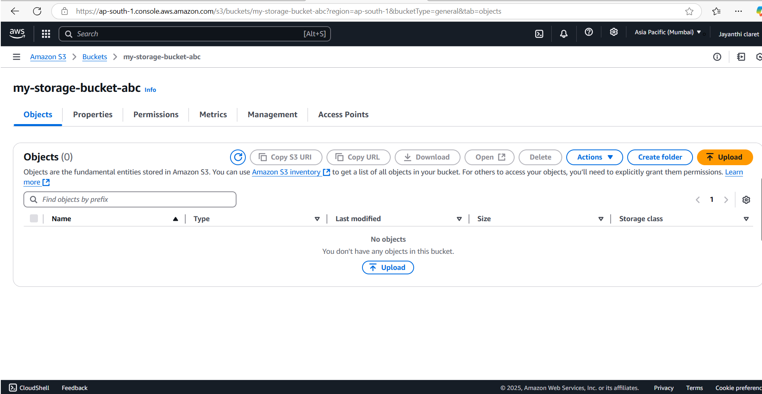

Step 6 :

Click "Upload" and then,

Drag and drop your file(s) or use the Add files button.Click Upload to complete.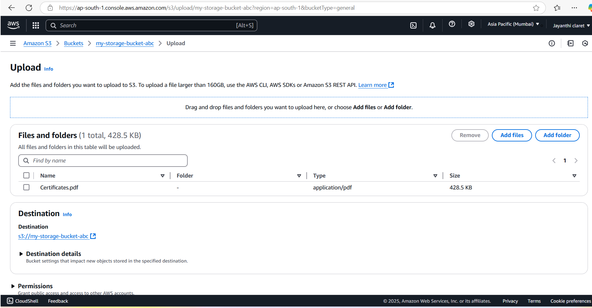

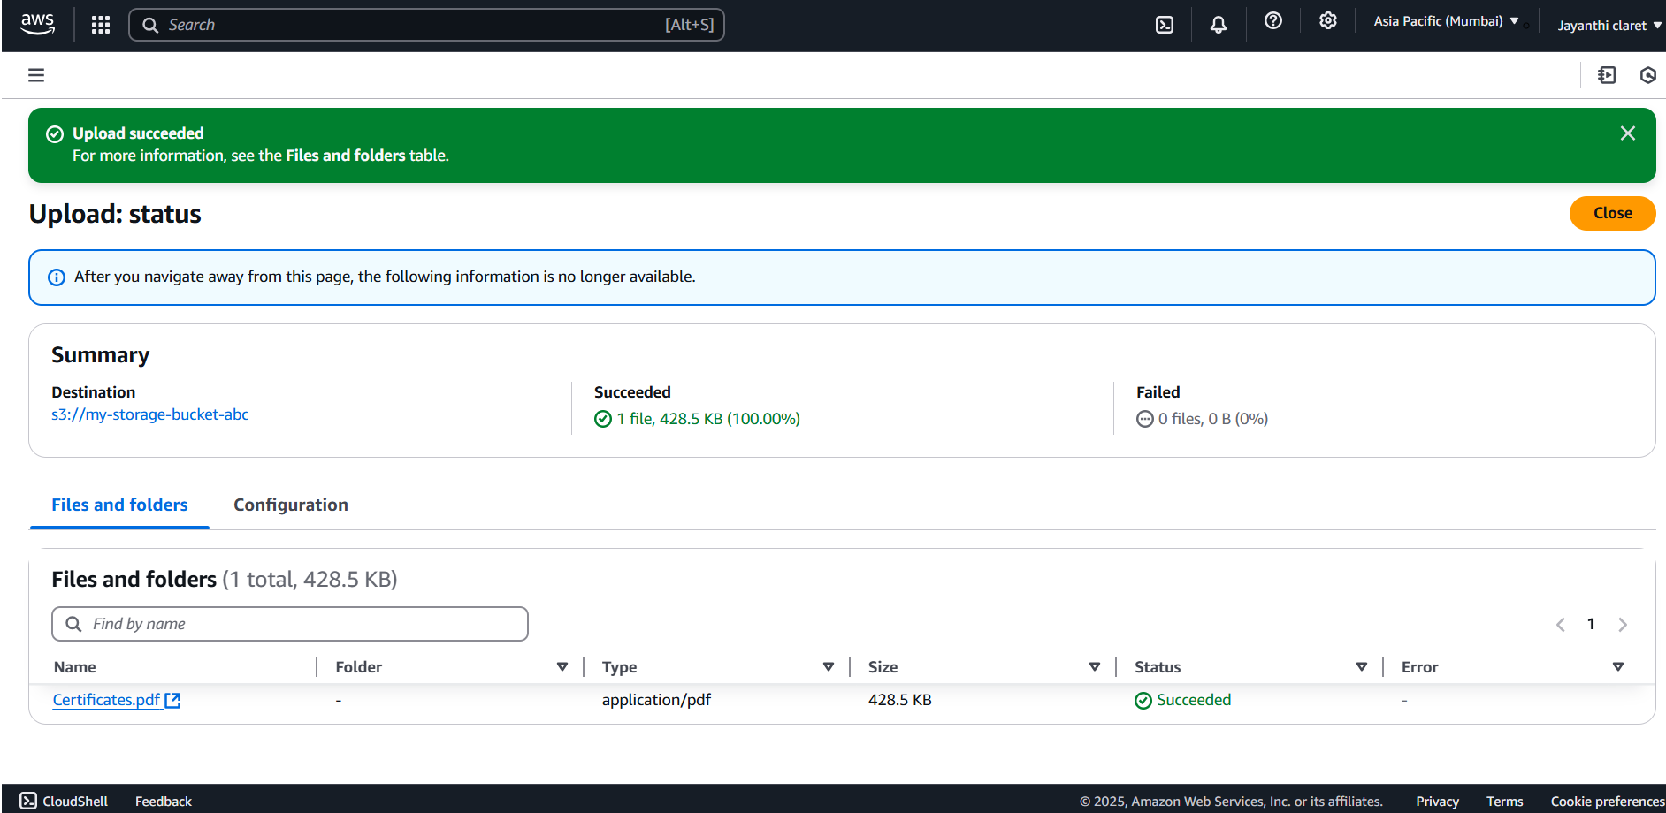

Step 7 :

Go to the uploaded file in your bucket. Click the file name to open its details. Select Download to save the file locally.

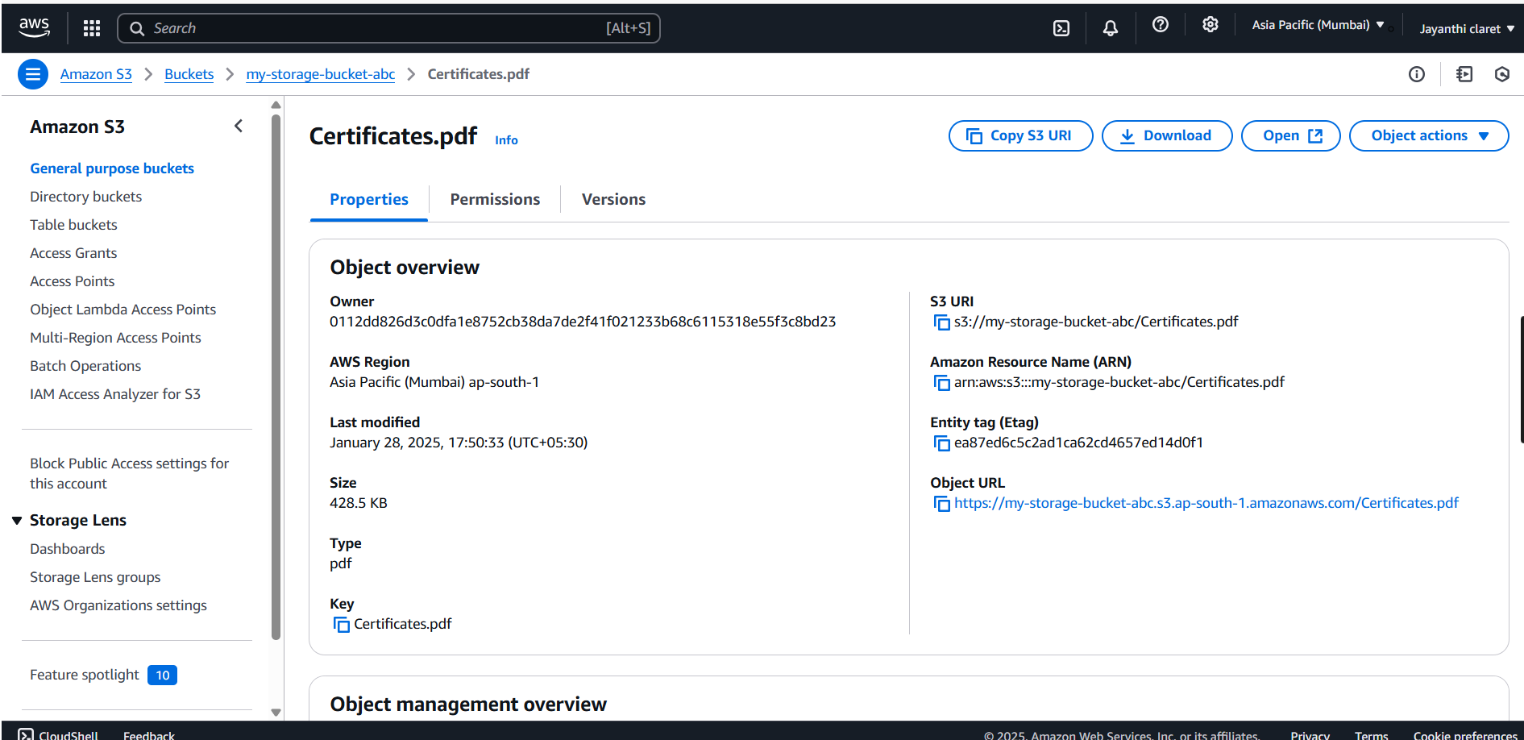

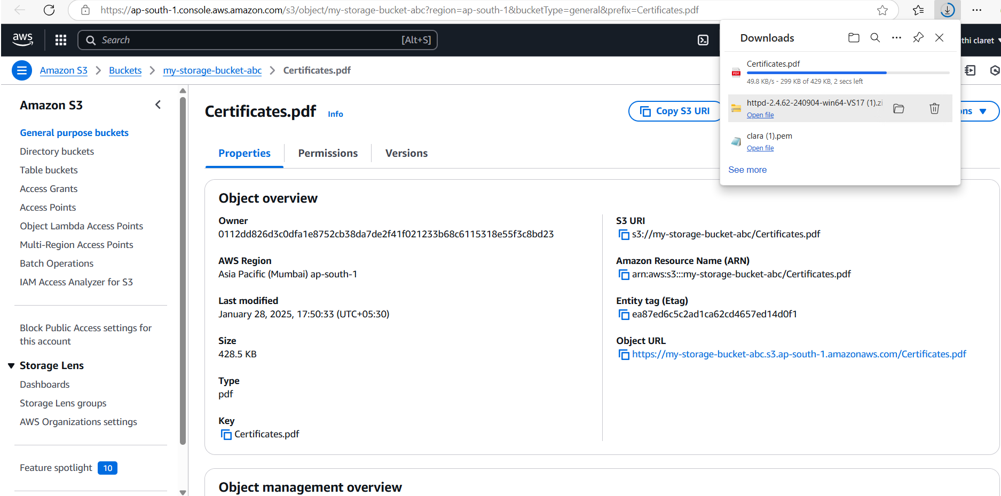

Step 8 :

Open your bucket and navigate to the "Permissions" tab.

Under Block public access, click Edit and uncheck "Block all public access". Confirm by typing "confirm" and save.

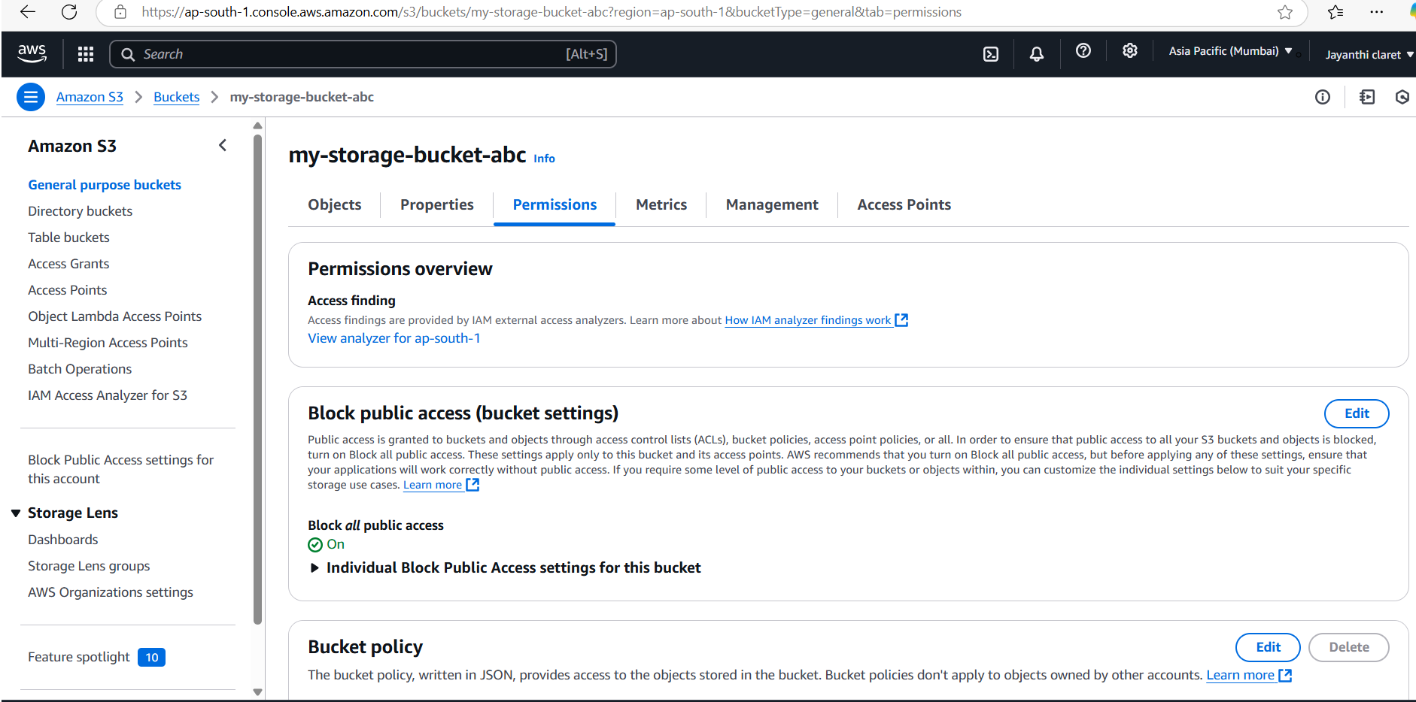

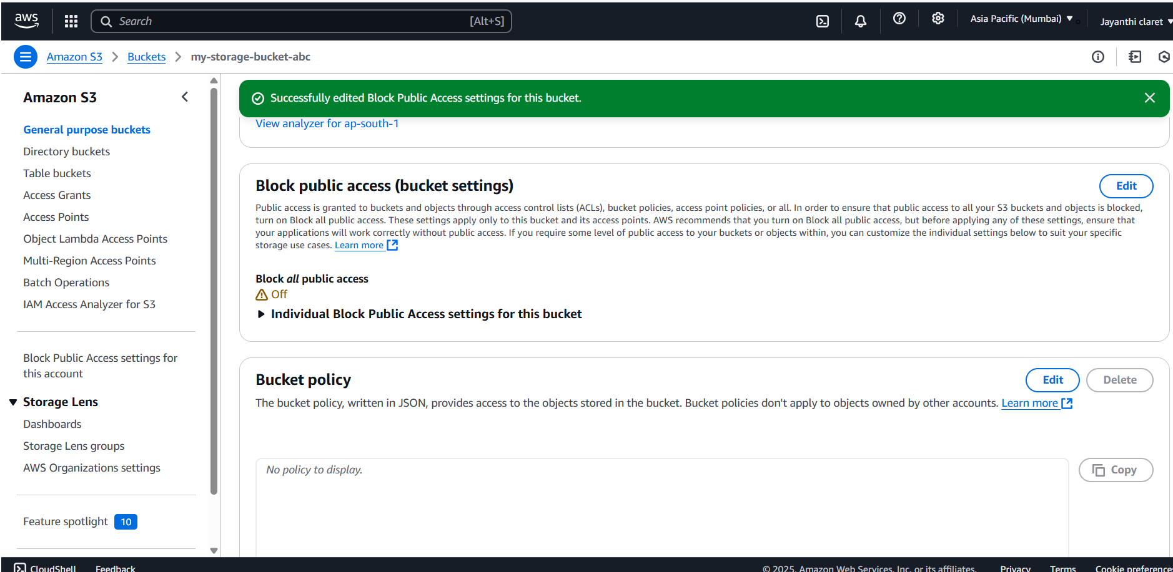

Step 9 :

In the "Permissions" tab, scroll to Bucket Policy and click Edit.Replace your-bucket-name with your actual bucket name.Save changes.

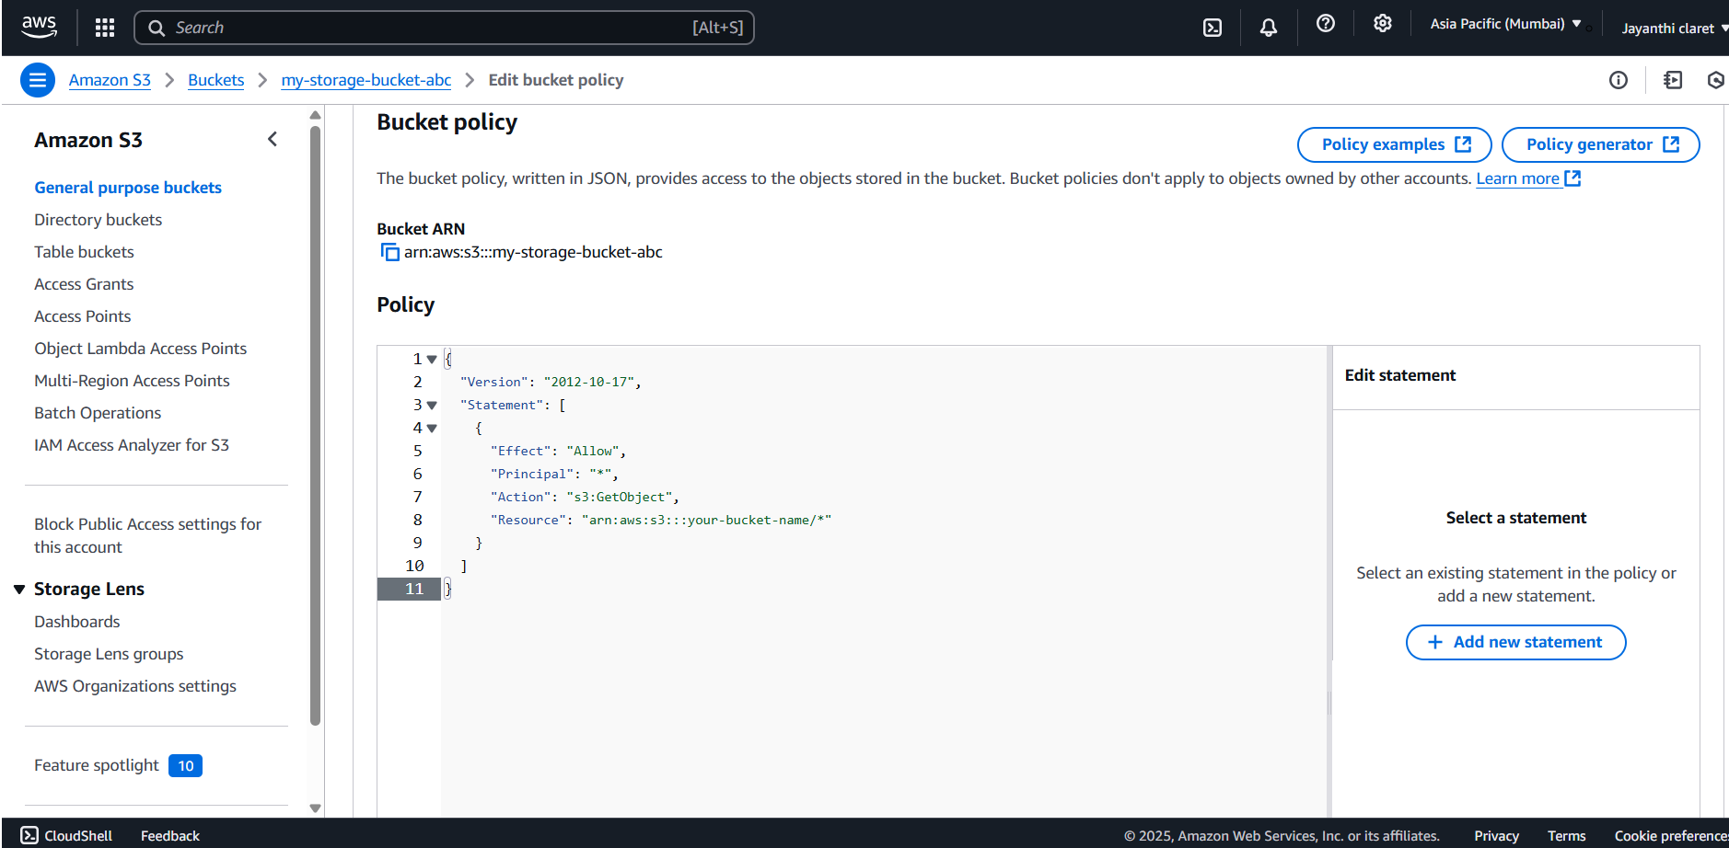

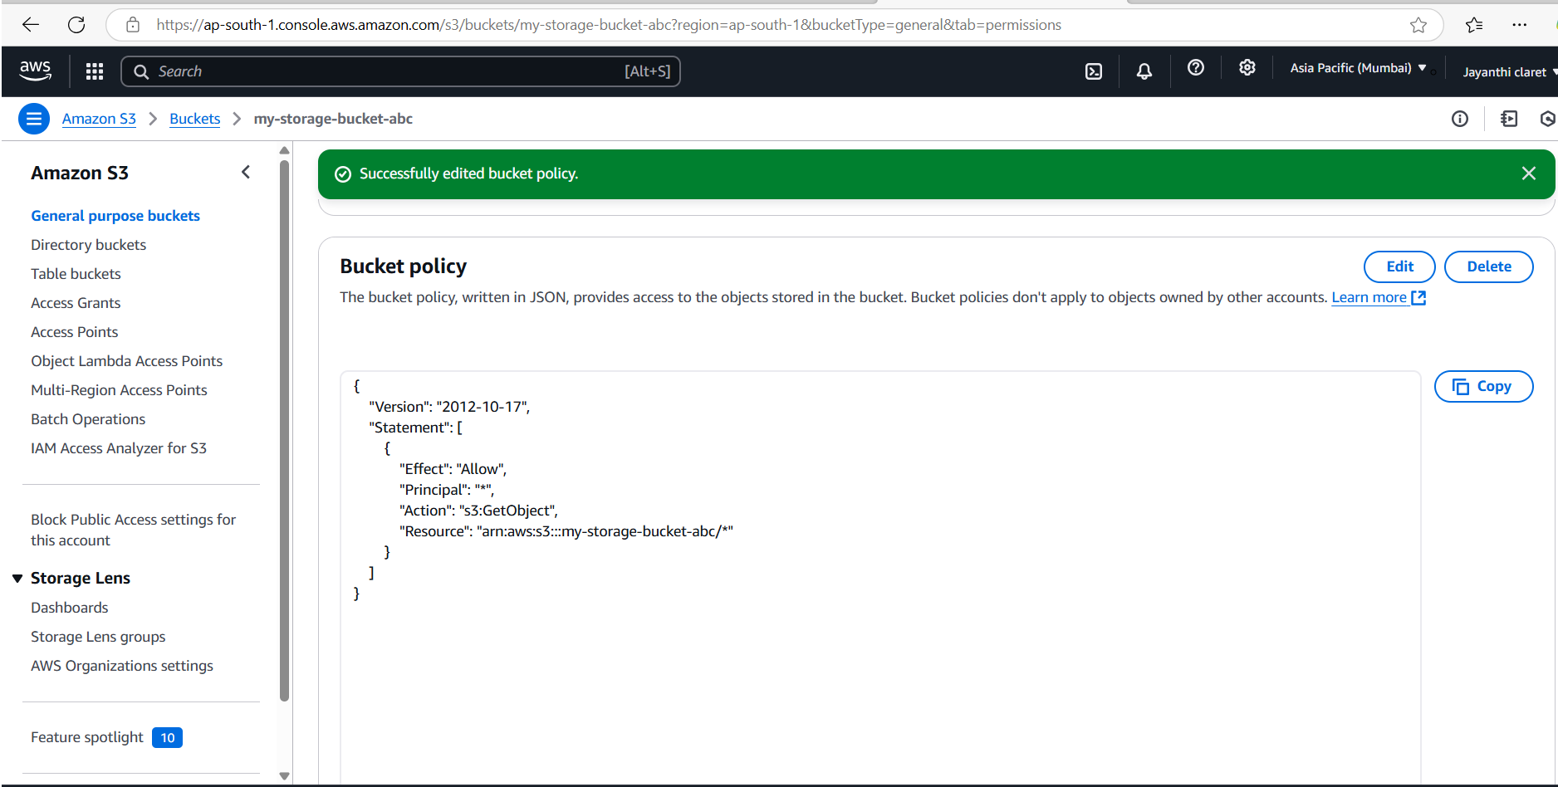

Step10:

Use the S3 bucket URL or public file URL to test access permissions.

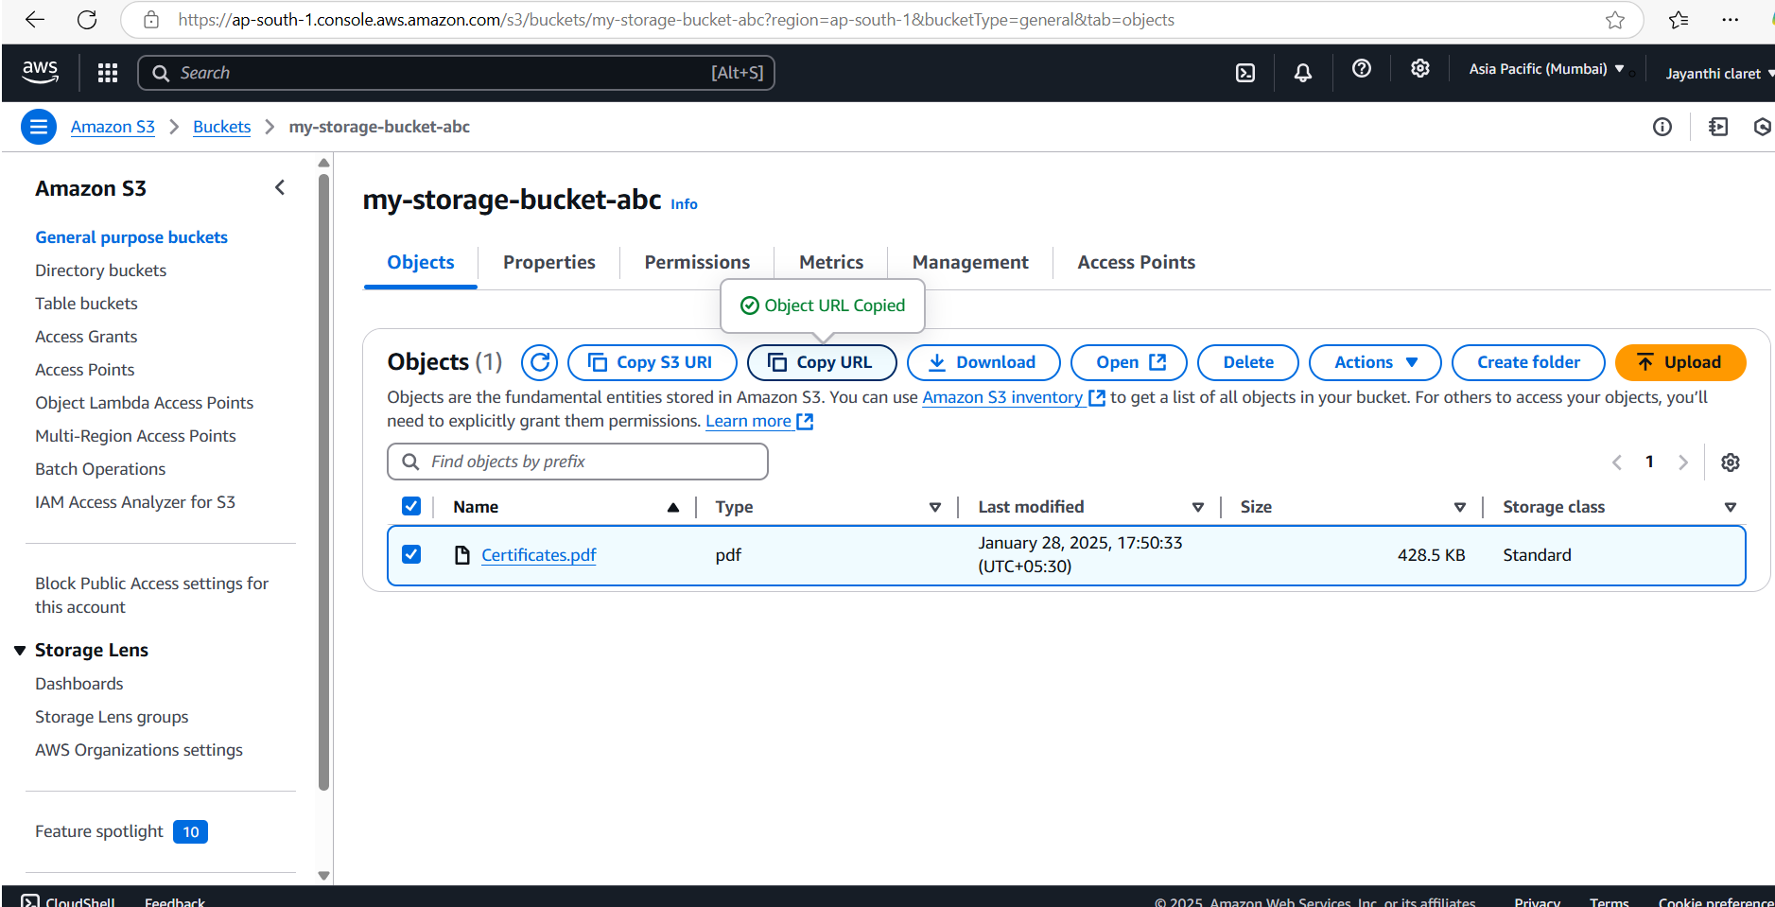



**Expected Outcome**

The outcomes of working with Azure Storage Accounts and Azure Blob Storage include:

**Data Storage and Retrieval:** You'll be able to store various types of data (text, images, videos, etc.) in the cloud and retrieve them efficiently.

**Scalable Storage:** You'll understand how Azure Blob Storage can scale to accommodate massive amounts of data.

**Data Security:** You'll gain practical experience in securing your data using Azure's access control and authentication mechanisms.

**Cost Optimization:** You'll learn how to choose the right storage tier (Hot, Cool, Archive) to optimize costs based on data access frequency.

**Application Integration:** You'll be able to integrate your applications with Azure Blob Storage to store and retrieve data programmatically.

**Data Management:** You'll understand how to organize your data within containers and manage its lifecycle using features like lifecycle management policies.

**High Availability and Durability:** You'll benefit from Azure's built-in redundancy and replication features, ensuring your data is highly available and durable.

**Disaster Recovery:** You'll understand how to use Azure Blob Storage for disaster recovery by replicating data to different regions.

**Performance Optimization:** You'll learn how to optimize performance by using techniques like caching and content delivery networks (CDNs).

**Foundation for Other Services:** Working with Azure Blob Storage provides a foundation for using other Azure services that integrate with it, such as Azure Data Lake Storage and Azure Backup.